

Headline goes here, headline goes here, headline goes here, headline goes here

Please note:

Before sharing this document with **external audiences,** ensure the document is converted to pdf format.

*The Fujitsu Infinity Pro Font is only available for use in Microsoft files internally and should not be embedded in files shared with external audiences.*

If presenting in Microsoft format, please ensure it is saved as a **Read-Only** document.

Subheadline goes here  
subheadline goes here  
subheadline goes here  
subheadline goes here

Select a Classification. © 2025 Fujitsu Australia Limited and subsidiaries

Contents

1. Guidance for Editing 3

2. Headers and Footers 5

3. Heading Level 2 6

3.1 Heading Level 2 6

3.1.1 Heading Level 3 6

3.2 Heading Level 2 7

4. Heading Level 1 8

A Annex 1 9

A.1 Annex 2 9

A.1.1 Annex 3 9

# Guidance for editing

In order to maintain a consistent visual standa rd there are a number of Text Styles accompanying this document. Please utilise these when formatting / making amends while using this template.

The Text Styles are accessible via the Style Gallery Window, see image below, this gives you quick access to your more commonly used styles including a visual representation of the applied style.

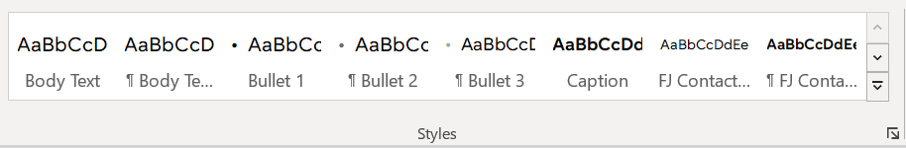

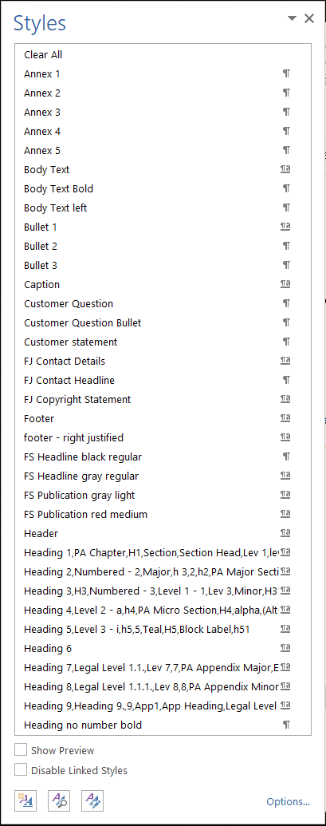  
Alternatively, by selecting the arrow icon  in the bottom right corner, a full list of available styles will appear with options for adding, editing and managing the styles, see image to the right.

Please note either of the above mentioned options, can be utilised individually or in tandem, provided the relevant styles are being applied there is no wrong method.

# Headers and footers

Locate the header or footer to be updated and right click to open the edit mode. Close the edit mode by clicking the 'Close' button on the 'Header and Footer' toolbar.

* The Document Title, Customer Name and Date will need updating in the Header
* The Company Name for the © Copyright needs to be select from the drop down in the Footer on cover and internal pages, and on the final page.
* Classifications allow you to ensure that information is protected according to its sensitivity. The higher the classification level, the more carefully the information must be handled. For guidance on Oceania Information Classifications please see [DSPU Information Classifications](https://fujitsuaus.sharepoint.com/sites/Oceania-collaboration/SitePages/Redirect-Security-Governance-Information-Classification-and-Management-Policy.aspx) site for guidance (Internal Link). After you have chosen a suitable classification, please select this from the drop down in the Footer on the cover and internal pages.

# Heading Level 2

Paragraph - Body text.

Subheading

* Bullet list – Bullet 1
  + Bullet list – Bullet 2
* Bullet list – Bullet 1
* Bullet list – Bullet 1
  + Bullet list – Bullet 2
    - Bullet list – Bullet 3
* Bullet list – Bullet 1.

Noster conclusionemque ad vel. Ea antiopam corrumpit per, nemore probatus mandamus in sed, eu ius dolores epicurei atomorum. Veri scaevola delicata vel ad. An saperet nostrum aliquando cum, adipisci percipitur vix ut. Postea vivendo praesent ius ex, mei ne inermis facilisis, an dolor omittantur cum. Usu eripuit principes ut, has an iuvaret dolorem luptatum, tollit repudiandae cu sed.

Customer question

Customer question bullet

Customer statement

## Heading level 2

### Heading level 3

Ea antiopam corrumpit per, nemore probatus mandamus in sed, eu ius dolores epicurei atomorum. Veri scaevola delicata vel ad. An saperet nostrum aliquando cum, adipisci percipitur vix ut. Postea vivendo praesent ius ex, mei ne inermis facilisis, an dolor omittantur cum. Usu eripuit principes ut, has an iuvaret dolorem luptatum, tollit repudiandae cu sed.

Lorem ipsum dolor sit amet:

* Bullet List – Bullet 1. Summo audire feugait at duo, ad eos audiam aliquip appareat. Ei ius mazim iusto vivendum, per in ornatus fabellas definitiones, mei ridens tamquam ad
* Bullet List – Bullet 1. Summo audire feugait at duo, ad eos audiam aliquip appareat. Ei ius mazim iusto vivendum, per in ornatus fabellas definitiones, mei ridens tamquam ad.

## Heading level 2

Paragraph to lead in to table – PreTable. The table style is pre-defined and should appear as a custom table when go to change the format of the table. After inserting a new table you may need to adjust the indent at the top of the document, to make sure everything aligns correctly. All Text Styles for the table are available in the ‘Home’, ‘Styles’ ribbon.

|  |  |  |
| --- | --- | --- |
| Table heading | Table heading | Table heading |
| Table text – first column | Table text | Table text. Lorem ipsum dolor sit amet, placerat convenire vulputate vix id, mentitum deserunt invenire pro ex |
| Table text – first column | Table text | Table text. Lorem ipsum dolor sit amet, placerat convenire vulputate vix id, mentitum deserunt invenire pro ex |
| Table text – first column | Table text | Table text. Lorem ipsum dolor sit amet, placerat convenire vulputate vix id, mentitum deserunt invenire pro ex |
| Table text – first column | Table text | Table bullet – level 1. Lorem ipsum dolor sit amet, placerat convenire vulputate vix id, mentitum deserunt invenire pro ex |

# Heading level 1

Lorem ipsum dolor sit amet, placerat convenire vulputate vix id, mentitum deserunt invenire pro ex. Duo facilisi conclusionemque an, adhuc omnes postulant ad vix. Cu eam dicit commune. Eu ius ferri animal.

1. List number 1
2. List number 1
3. List number 2
4. List number 2
   * + List number 3
     + List number 3
5. Annex 1

Lorem ipsum dolor sit amet, placerat convenire vulputate vix id

* 1. Annex 2

Lorem ipsum dolor sit amet, placerat convenire vulputate vix id

* + 1. Annex 3

Lorem ipsum dolor sit amet, placerat convenire vulputate vix id

* + - 1. Annex 4

Lorem ipsum dolor sit amet, placerat convenire vulputate vix id

* + - * 1. Annex 5

Lorem ipsum dolor sit amet, placerat convenire vulputate vix id



©2025 Fujitsu Australia Limited and subsidiaries. All rights reserved. FUJITSU and FUJITSU logo are trademarks of Fujitsu Limited registered in many jurisdictions worldwide. Other product, service and company names mentioned herein may be trademarks of Fujitsu or other companies. This document is current as of the initial date of publication and subject to be changed by Fujitsu without notice. This material is provided for information purposes only and Fujitsu assumes no liability related to its use.

Select a Classification. Uncontrolled if printed